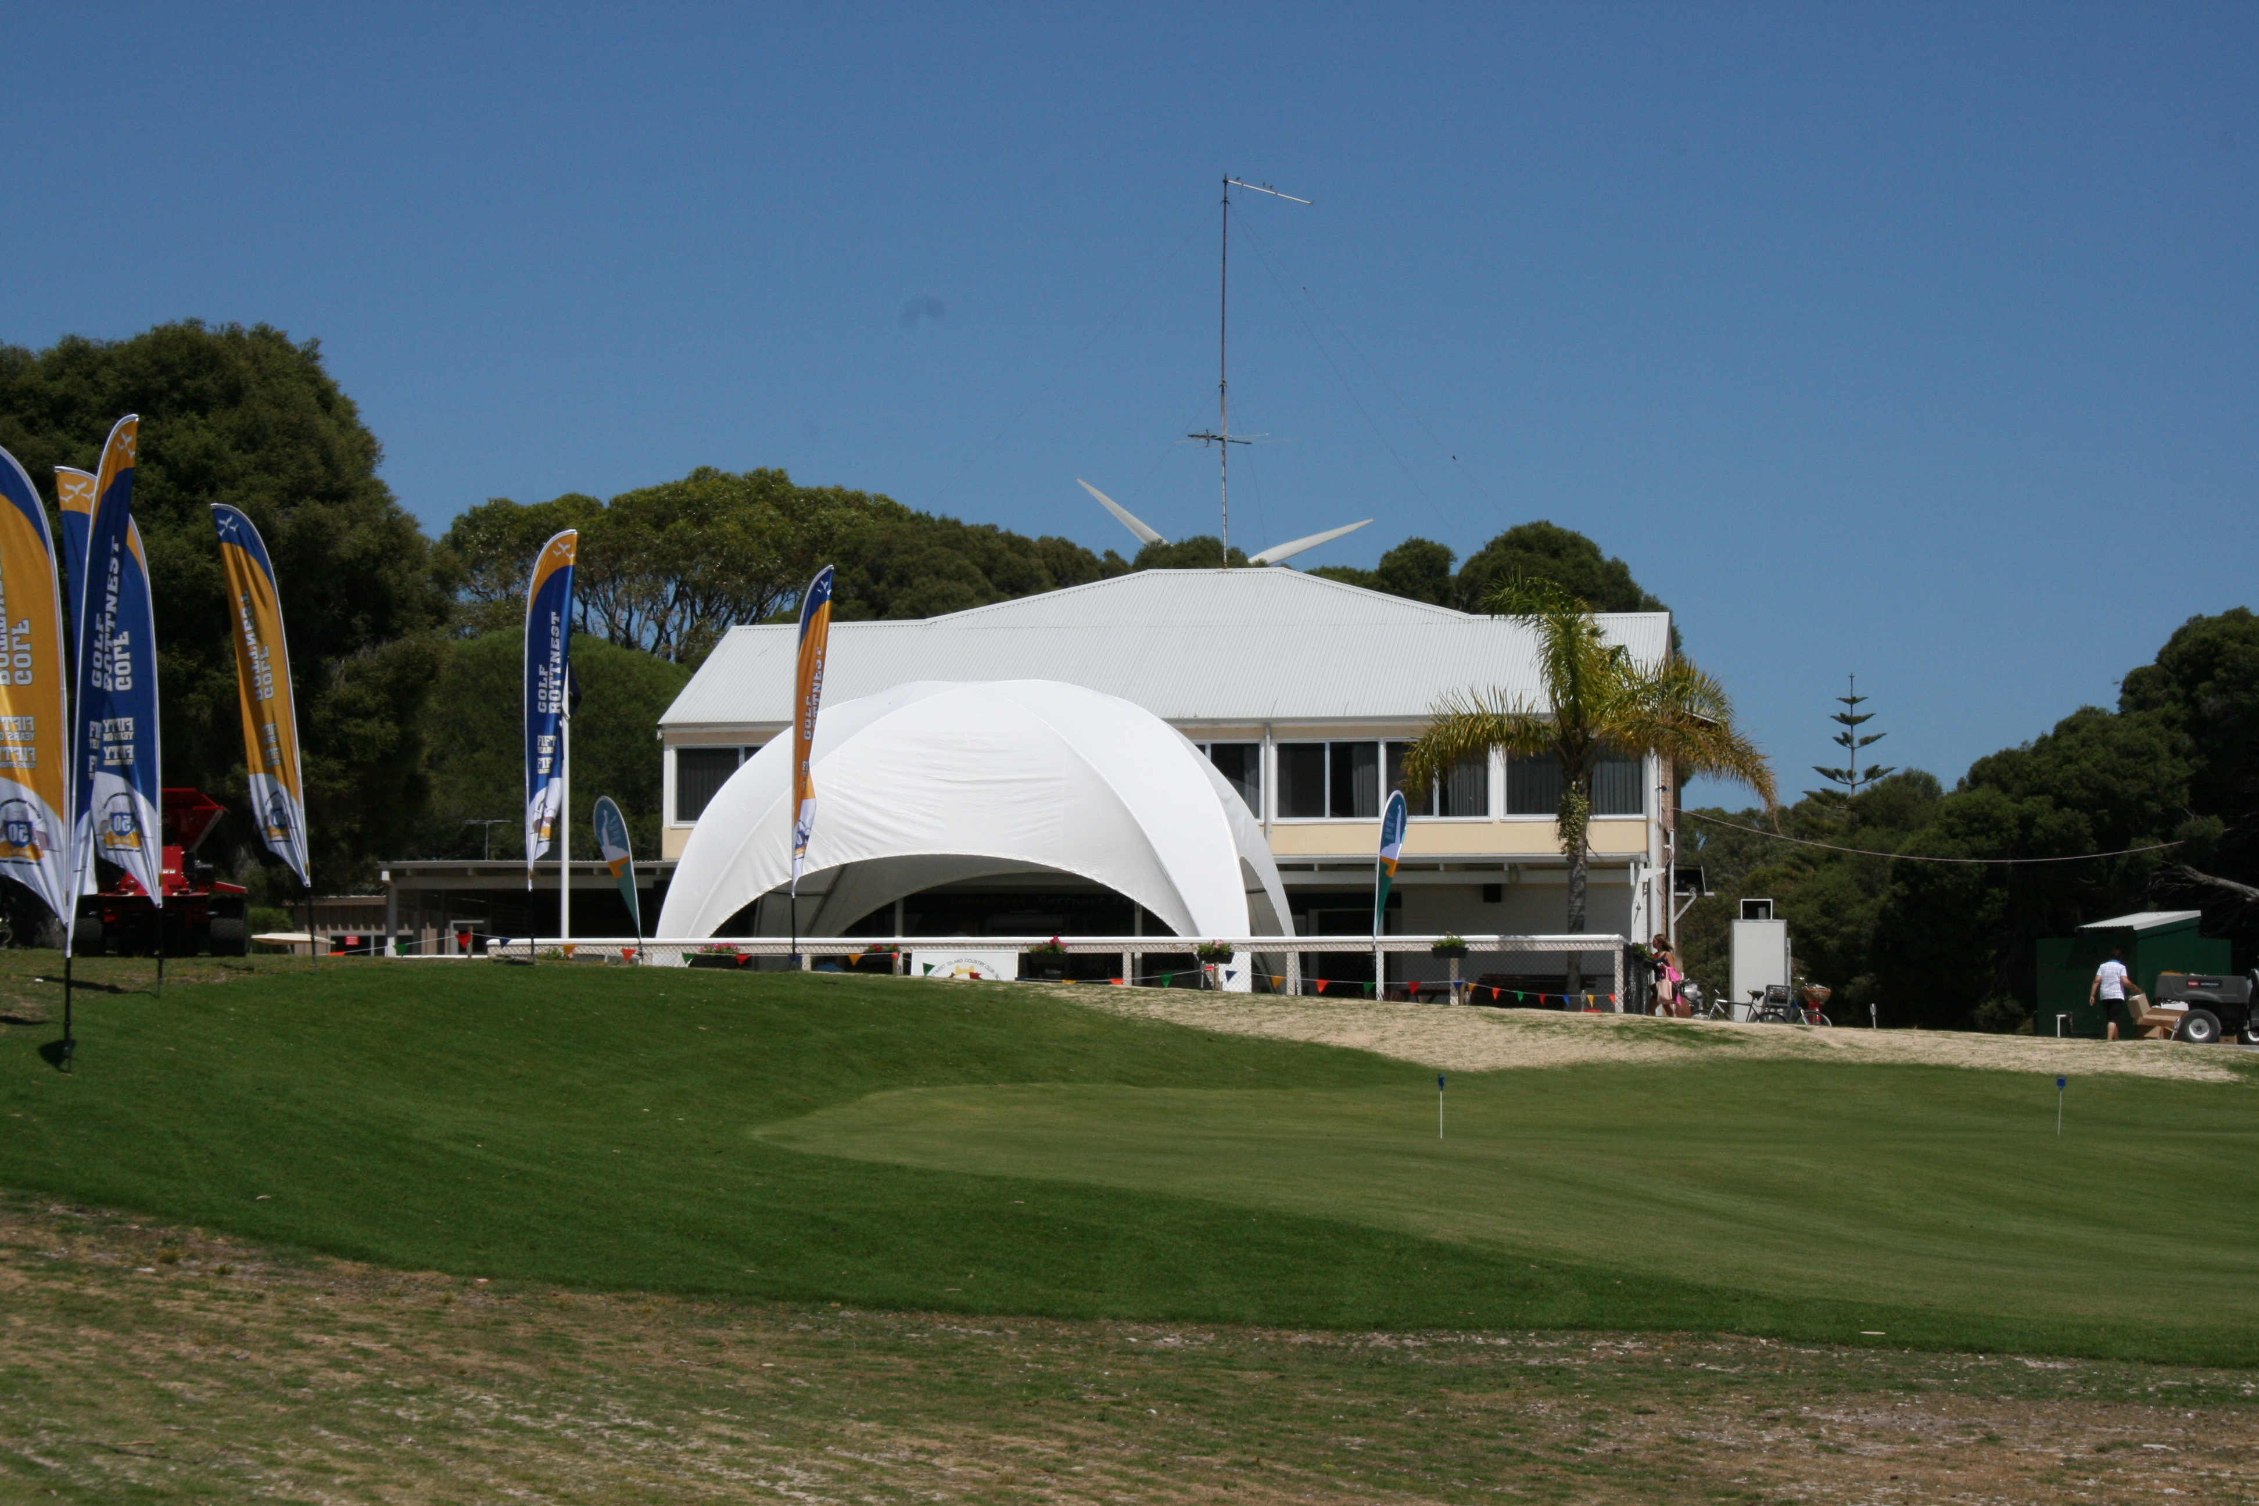

Members and friends of Rottnest Island Golf Club,

The season opening was held over the weekend of 14 to 16th of March.
Friday’s Stableford competition had 17 enthusiastic golfers vying for bragging rights on the first day of Opening weekend. It was noticeably warmer on the Island now that the all year round golf course allowed an earlier start to the season than previous years. This early start did cause several members to submit apologies as the timing clashed with other things happening on their schedule.

A word from the Doc Golf on the rock.
Friday's weather was perfect, beaut sunshine and gale force winds, although that was my excuse for my ball not travelling far. Matt R won everything and Jenni, Wendy and Esther won everything else. So as your new handicapper I accepted huge bribes and as will be later proved, the ladies won everything the following day. Friday evening witnessed some incredible drinking competitions with Glen and Steve M in total control. Now elevated to near Olympic representation and both will carry our club flag. Both jilted me to view the Shockers rout Collywobbles. Saturday, under the watchful eye of President JP, the Chairman's Cup (sic) proceeded without a hiccup. Unfortunately Dish, Barry Mac and that Shipperd lad were given a massive handicap by being forced to partner the handicapper who came in with a 139. Laughter was the best medicine for all that attended, and the day was punctuated with massive screams of joy as various balls disappeared down 4 inch round receptacles (normally without intent). Once again balmy weather was ideal; our foursome had to follow perennial champions Merv and Wendy so we hit up on them all day. One particular member on the fourth, hit to the green on both rounds to disturb their concentration. (Not the fourth green but the one on the right). Gavin and Glenn won the wine sipping competition by four bottles. Scotty and JP won the Chairman's trophy by a nose, representing the Rotto Golf Club, and the later speeches by Rotto CEO Paolo Amaranti and Rotto Board Chairman John Driscoll were amazingly concise and correct. Scotty attempted to take Glen and Steve's new crown by remaining in the free standing position until 1.0 am, however when mendaciously boasting it was discovered he had a stubby in his pocket. So whilst he was subjected to scorn; he was rejected then he was ejected from the pub. Sunday witnessed some ambulatory wounded, three retired hurt, Noddy had returned to the mainland; Scott Jones appeared unshaved when lunch was being served, therefore absent without leave and fined. The only optimistic, impeccably dressed member was JP (it was later discovered he had his missus on the island). However, sixteen members made the cut and once again perfect weather for PAR. Dismal results followed with numerous minus-fives indicated our aged Rotto motto and tradition were being espoused. I was being protective of Esther's better-half Greg by paternally instructing him cautiousness for snakes near the McNab area, when a HUGE (about two feet) Mr Dugite appeared at my feet. My speed of movement returned to half a century ago as a wing-three-quarter, so fast that my Crocks nearly fell off. Jenni won the lot (she was the only female left demonstrating excellence and resilience). Secretary Phil explained a golf measurement device as we were collecting the markers, and was very considerate when I fell asleep and tumbled out the cart. The returning two o'clock ferry demonstrated the sturdy by those who approached the bar. Big thanks to Matt and Lisa who kept us fed and watered and to JP and Phil who did all the work. Mark your diary for our Classic in May 23-5 and see you on the rock. Keep swinging. Doc
The worthy winners on Friday were:
Men’s
1st Matt Rodoreda on 19pts
2nd Steve Matenga 18pts
3rd Scott Jones 17pts and
John Peddie 17pts
5th Greg Whitmee 16pts
Ladies
1st Esther Whitmee 15pts
2nd Jenni Rowley 11pts
Wendy Lockhart 11pts

Near to pin
Merv Lockhart Jenni Rowley
Long Drives
Merv Lockhart Wendy Lockhart

The Chairman’s Cup saw an increase in the field with 22 names entered into the game register. Handicapper Tony Thatcher was there at the crack of dawn making sure players that had not pre-nominated a partner were looked after admirably. The Doc acted as starter and photographer of the playing groups.
The winning Pairs:
1st John Peddie and Scott Jones 62 net
2nd Barry McGougan and John Dishon 64
3rd Jenni Rowley and Phil Bray 67

Near pins Ray Turnbull
Esther Whitmee and Jenni Rowley

Long Drive Steve Shipperd
Wendy Lockhart

Sunday Par event
Winner 1st Glen Trebilcock -1
2nd Matt Rodoreda -2
Barry McGougan -2
Long drive Steve Matenga
Near Pin Jenni Rowley

A word from the President
Great weekend, as usual! Thanks again to Matt, Leisa, and Ian for the cooking and Glen for looking after our needs at the Lodge – you guys sure make the weekend easy. Also good on the general and match committees for picking up the ball when and where required – it’s just a dress rehearsal for the next couple of events, which should be BIG ones.

Of course a big round of thanks to Chairman John Driscoll for making a special trip to the island to present his trophy and mix with the members – also CEO Paolo Amaranti.

Entry forms for the Classic should be out within the next couple of weeks, and The Lodge has plenty of accommodation put aside for us.

Photos of weekend will be uploaded to Flickr site shortly.

If you use the Sureshot GPS device to assist your distance gathering information on the course, you can now download the Rottnest Island Golf Course map from the Sureshot website. The club secretary mapped the course after the game on Sunday. Check it out!!!

