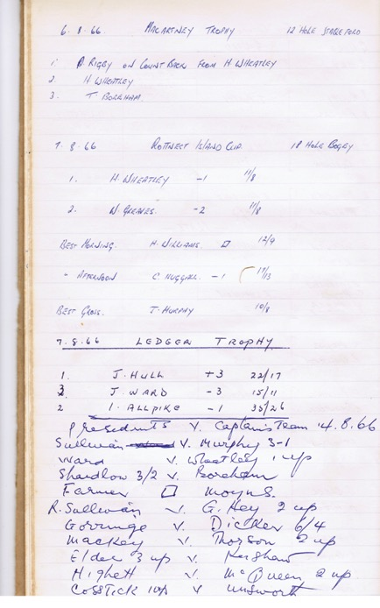

Dear Members and Friends of the Rottnest Island Golf Club.

The response from members for this years Cup is very encouraging. You had to be quick submitting an entry as the field filled within the first week and a half. The management committee had to take the unprecedented step of closing the applications off early. There are several new members entered to play along with friends of members that have raised the playing field to 112. The President’s Cup and Elgar O’Mahony Memorial days are also well patronized well into the 90’s entrants for each event.

More on the way it was.

Set out in this newsletter is a snap shot of record books that have been kept to reflect back on the tradition that the Golf Club has over the years. I hope you recognize your name and others that have been an integral part of the Club’s History.

*The tradition of the Rottnest Cup and Ledger Plate became a main event from the beginning.*

**Lead into the Cup 2016 Classic**

News Letter 19

more on 2

Rottnest Dome Trophy

<Rottnestgolf.org>

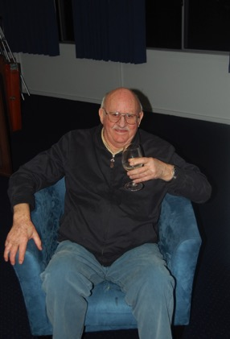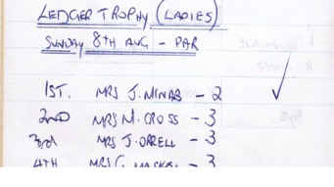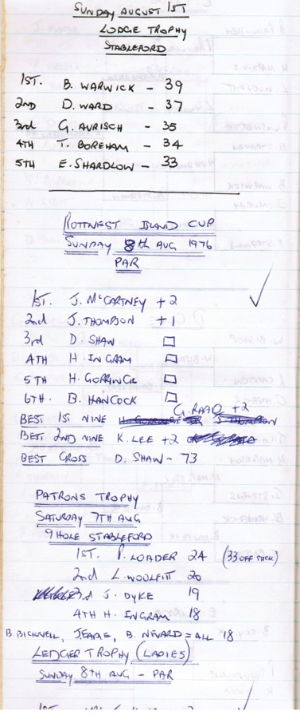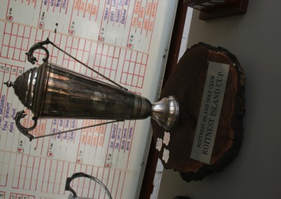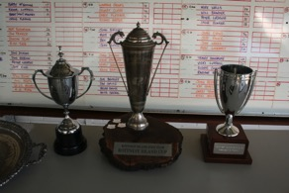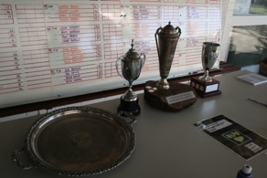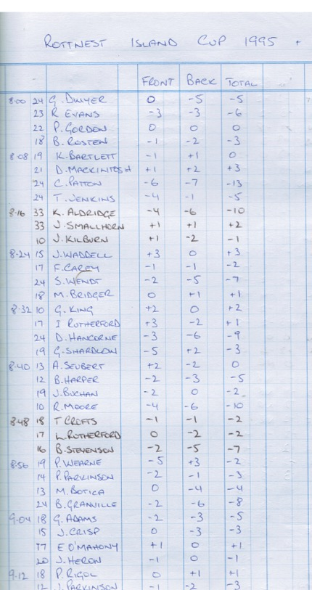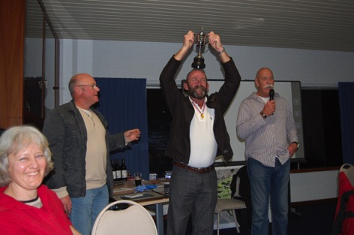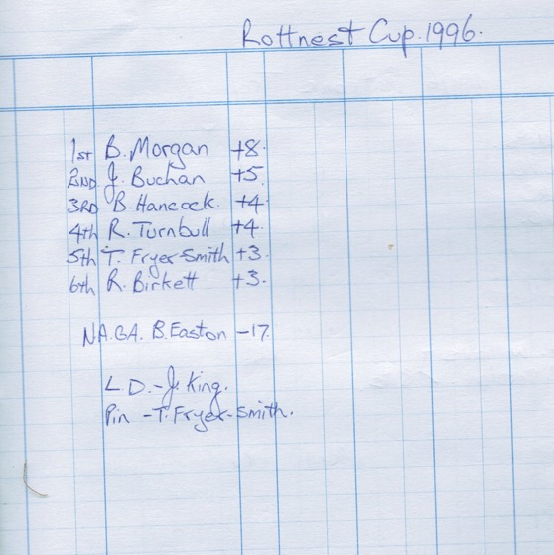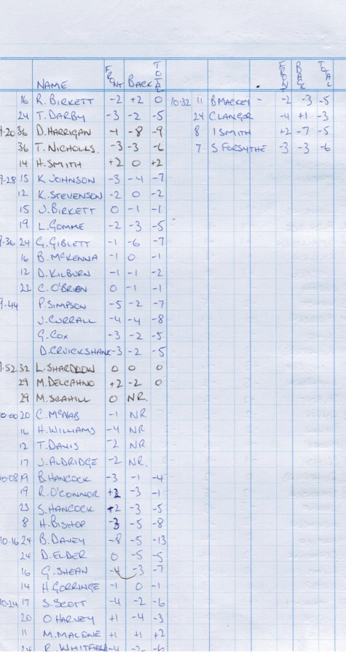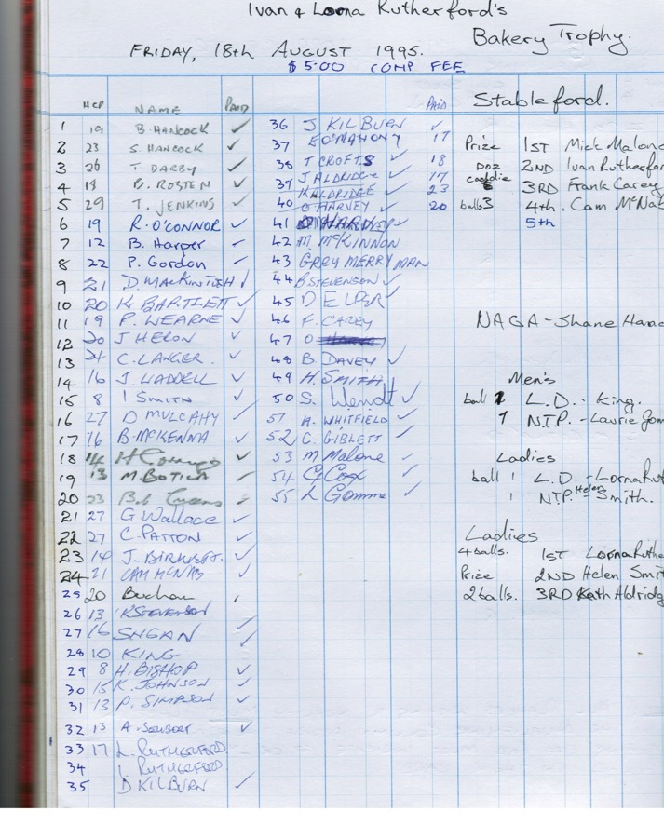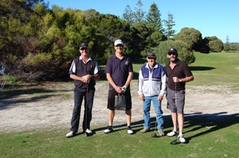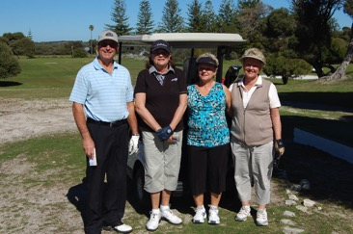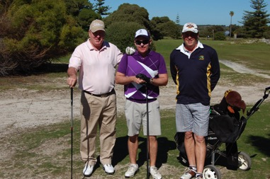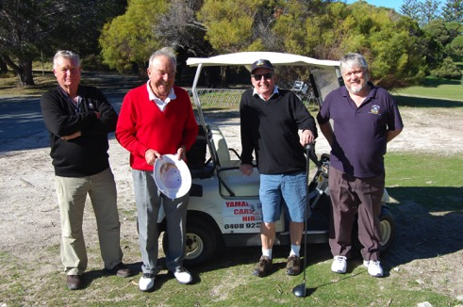

2016 marks the first year that Rotto Golf Club life member, Herb Williams, will be forced to discontinue venturing to the island due to his tired body just not able to make the trip any longer. Indeed, last year’s Cup saw a brave face on our longest standing member as he ventured to the course for the last time. Herb has presented in every Rottnest Cup since its inception in 1961, and is the only one to do so.

 We the members stand proud of this life member, who has exhibited the absolute values of clubmanship. Don’t think for one minute though that we are making Herbie out to be an angel; in fact those that know him will say that he’s always been a naughty, naughty boy.

We’ll miss seeing you but you'll be with us in this year’s Cup in spirit Herbie, and many more to come.

Club and Cup Legend Herbie Williams

Good Golfing

Phil Bray

President RIGC

The Tradition continues with regular members always penciling in the Rottnest Cup and Ledger Plate as a must do on their golfing calendar